Sales By Segment Analytics

Choosing Template

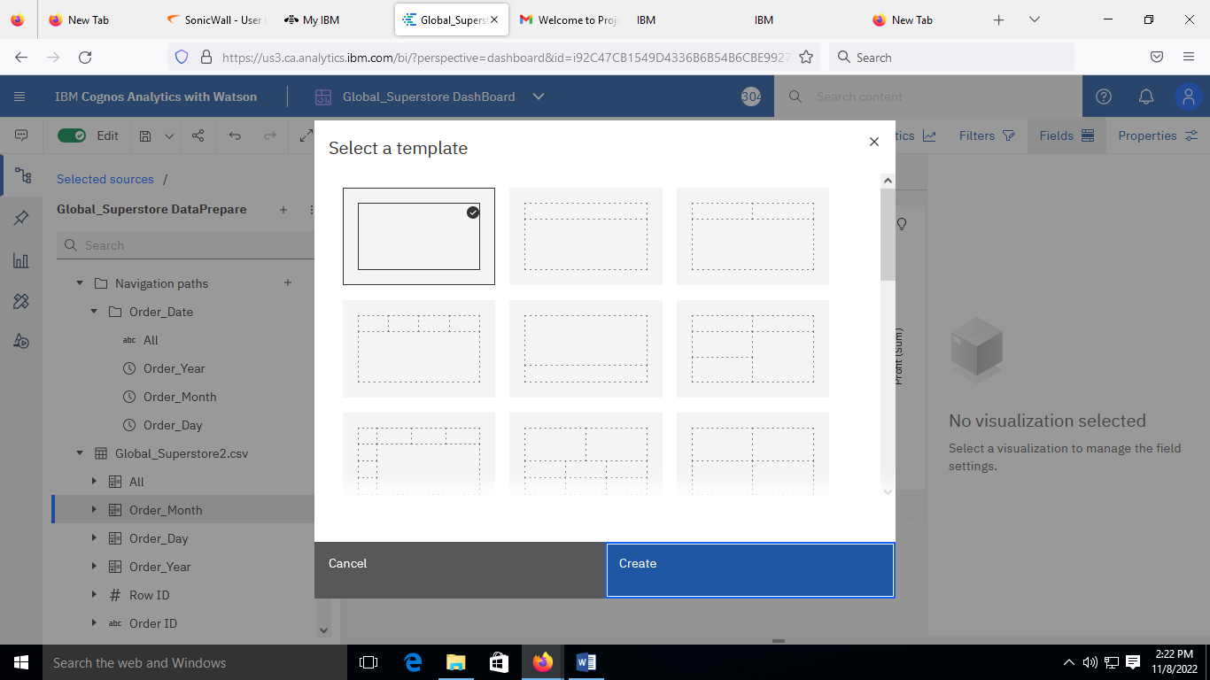

Vis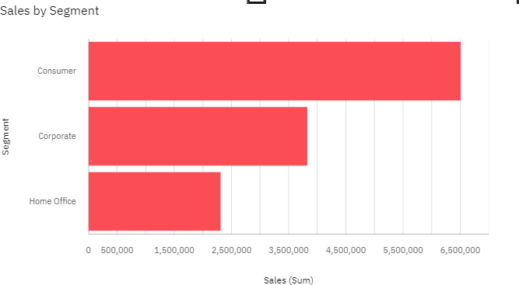ualization for Sales By Segment Analytics